Solent University

# **Web Technologies Supporting Documentation**

Student number: **10181827**

Modul title: **Web technologies**

Modul tutor: **Dr Sahbi Ben Ismail**

# **1.Overview**

I created a website about Online Film Festival. The website contains 4 different pages: Home, About, FAQ, Contact. The idea of this page is that user can see which movies are going to be displayed and get to know a little more about the movie by clicking on the image which will redirect the user to the Imdb.com website (the world biggest data base with movies). The festival is free to access to everyone, as it is promoting art during pandemic times and no tickets are required.

# **2.Pages**

## **Home Page:**

After hovering on the image, it zooms out and after clicking on the user is moving to a different website. There is also a fully responsive menu bar on a top right side.

# 

The bottom part of the side.

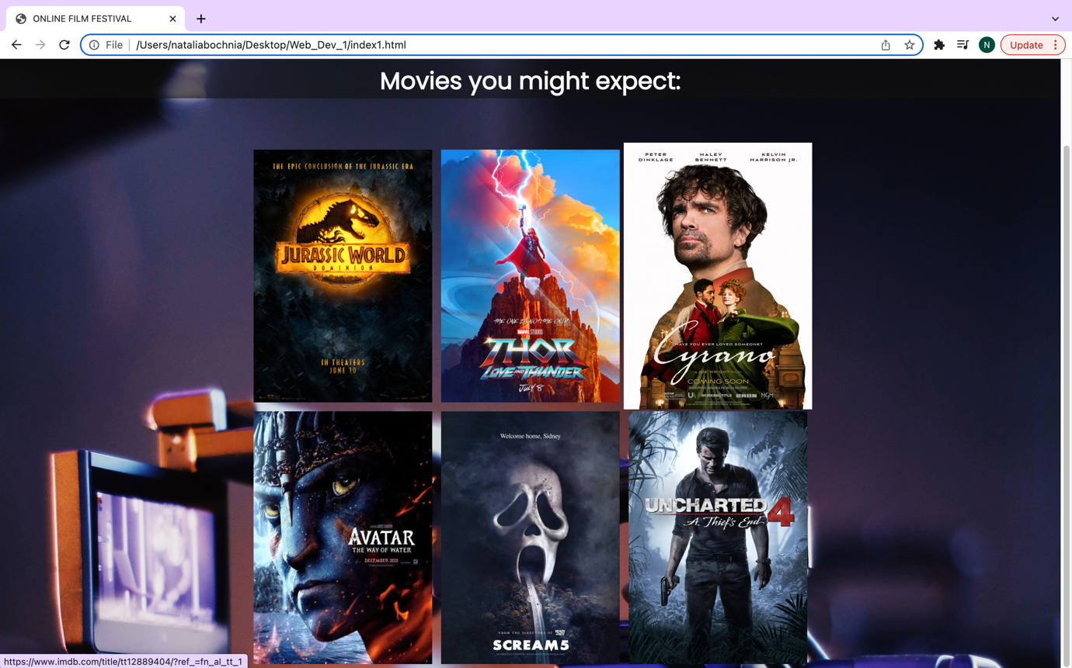

## **About Page:**

This is a second page, where I am briefly explaining what this festival is about, why is it happening and how covid has affected movie industry.

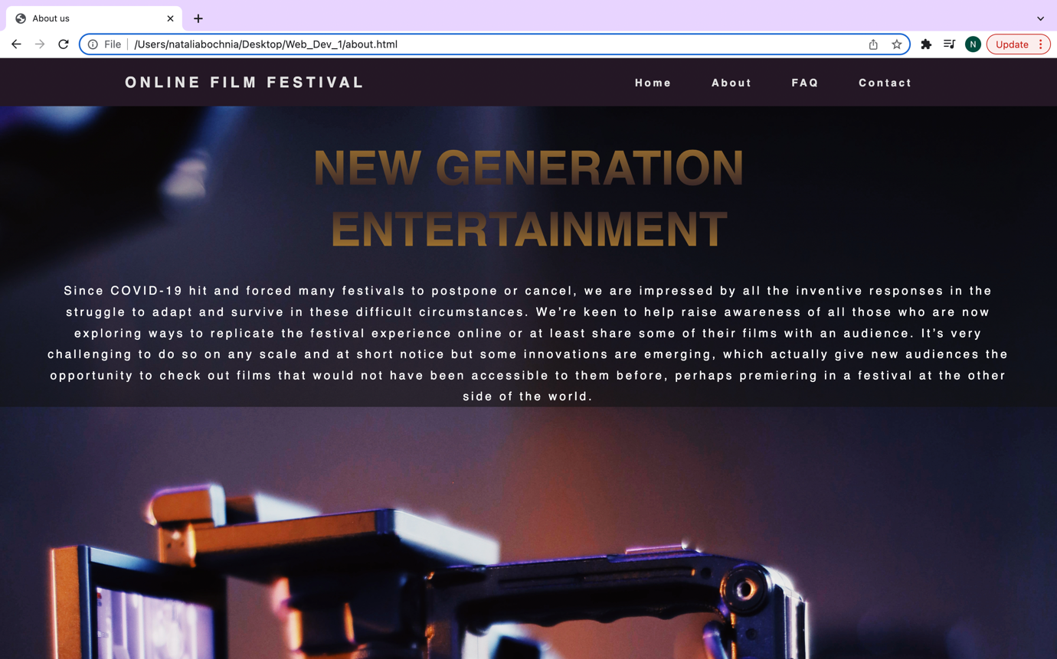

## **FAQ Page:**

This page is where I am answering frequently asked questions. I used a JavaScript to create a nice fully responsive collapsible section.

Default setting:

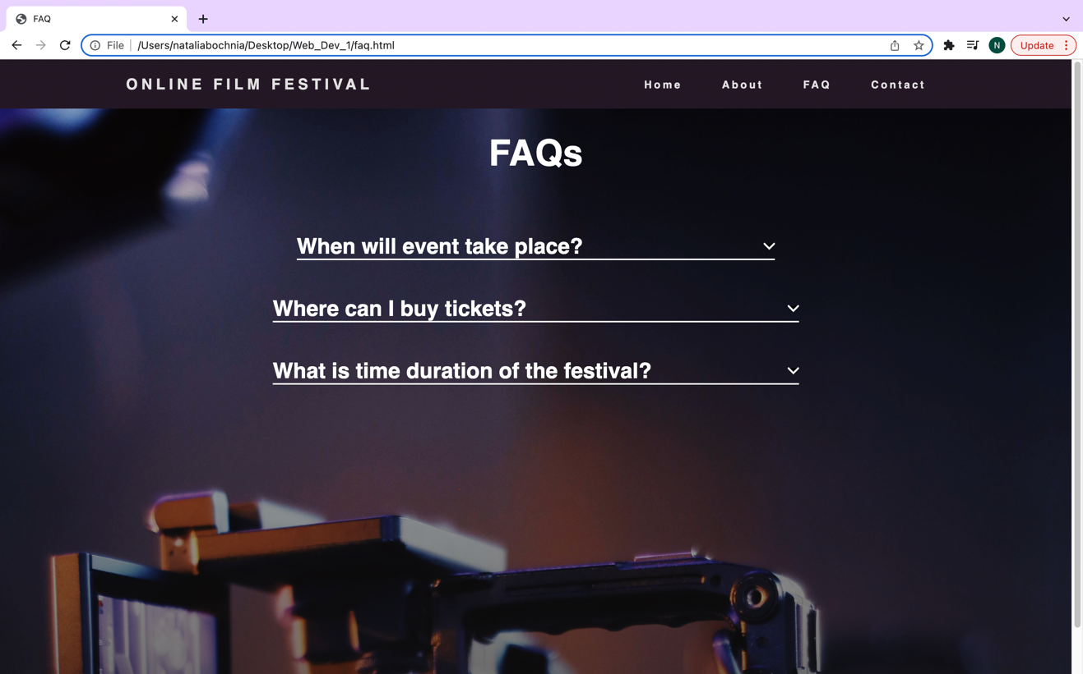

After unfolding:

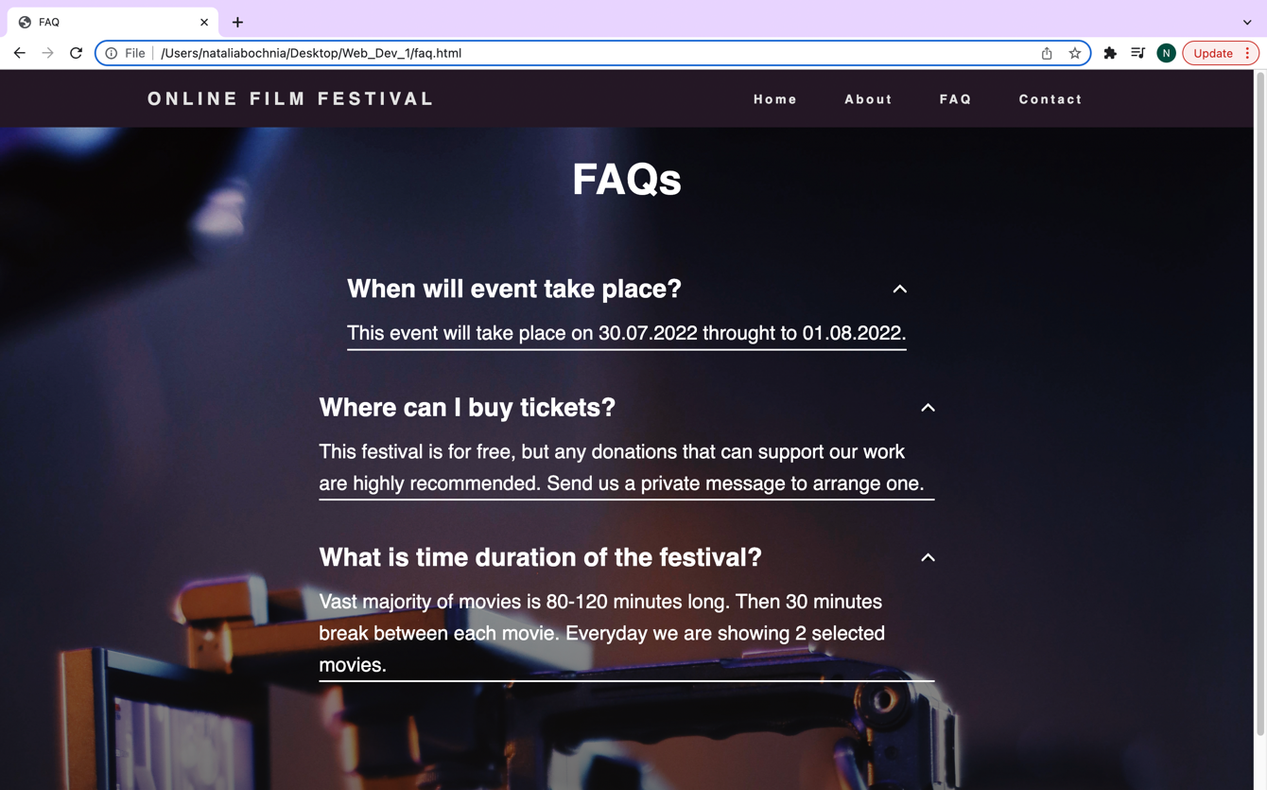

JavaScript Code:

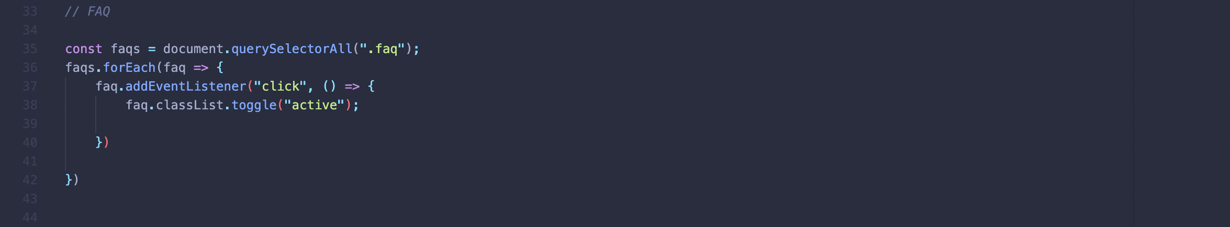

## **Contact Page**

This is my contact page. It has validation made by using JavaScript. You can’t submit your contact details if any of the information is missing. After filling up everything the “Thank you” note is displayed.

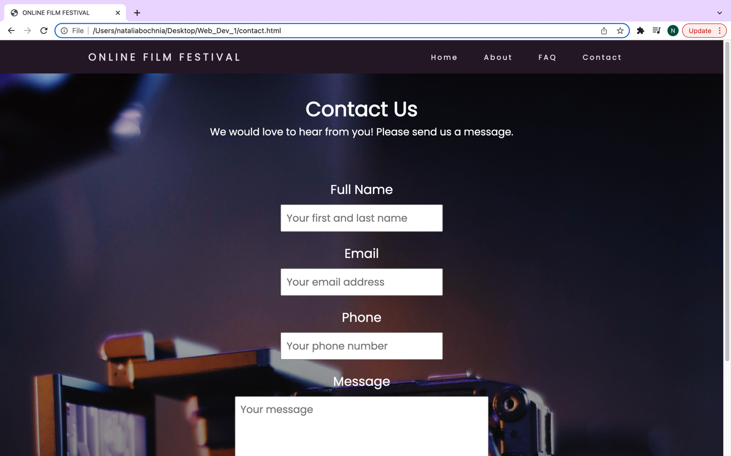

The bottom of the page: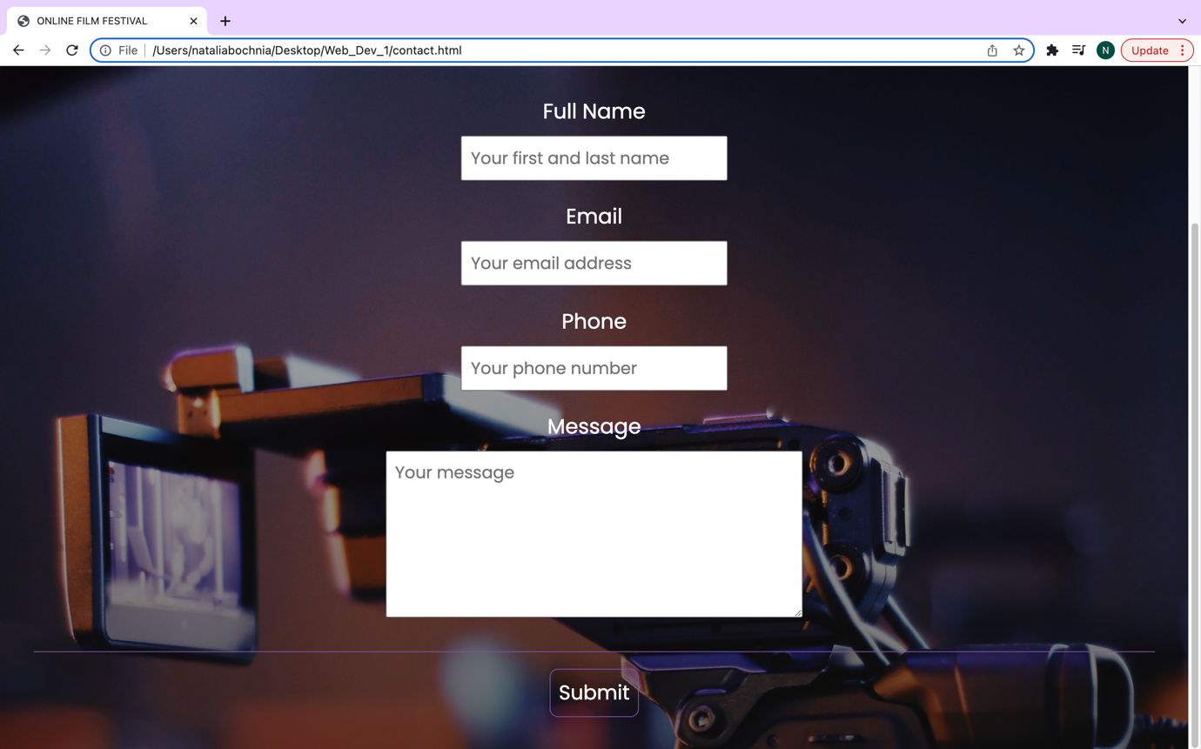

Validation:

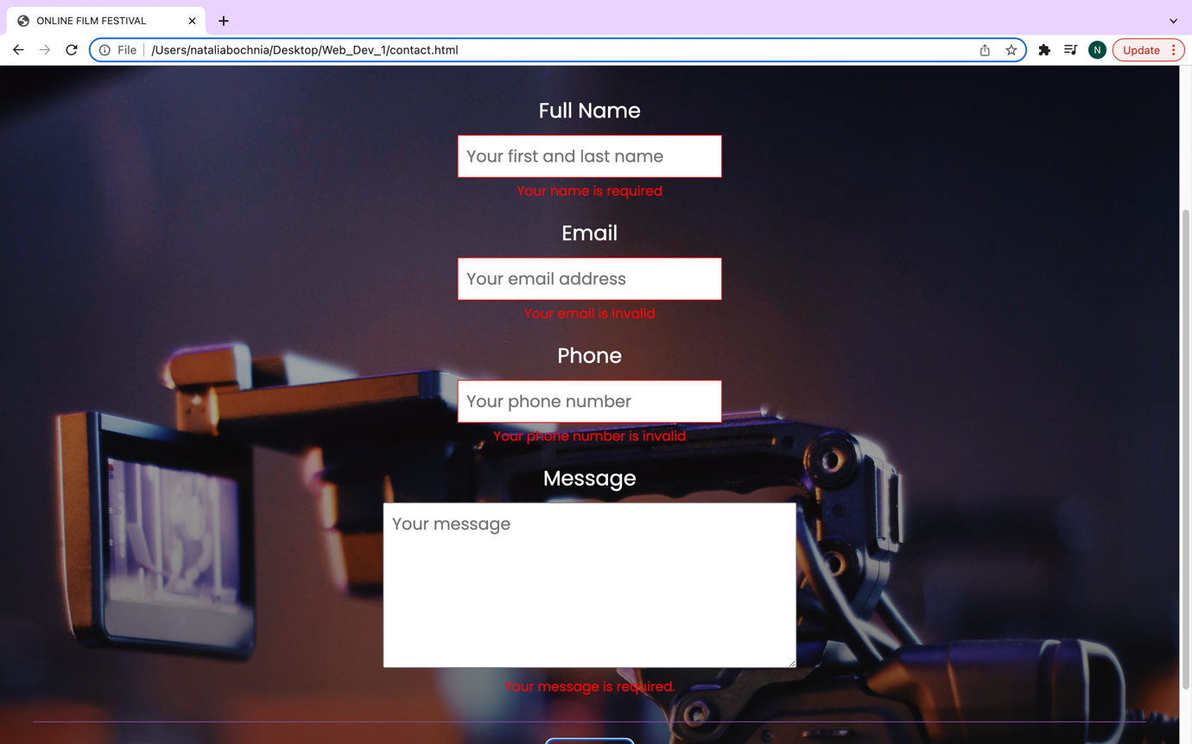

Submitted form:

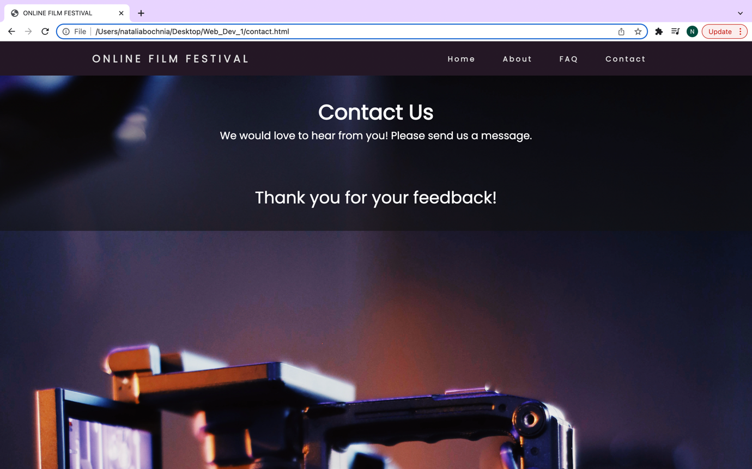

JavaScript code:

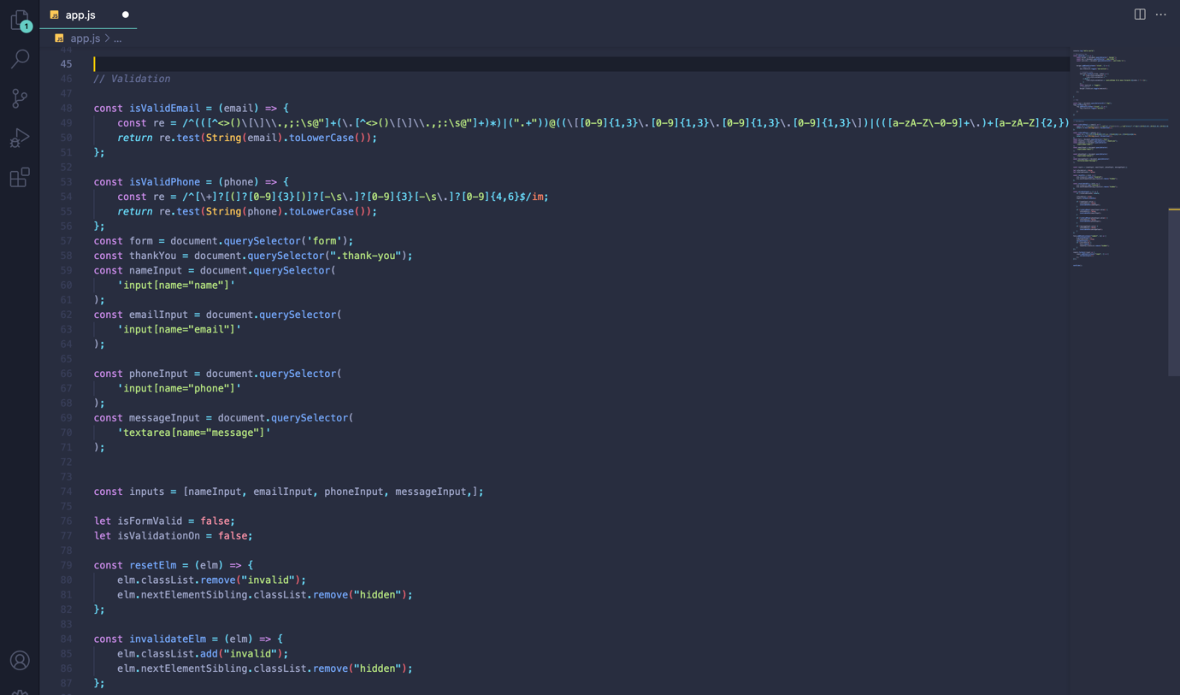

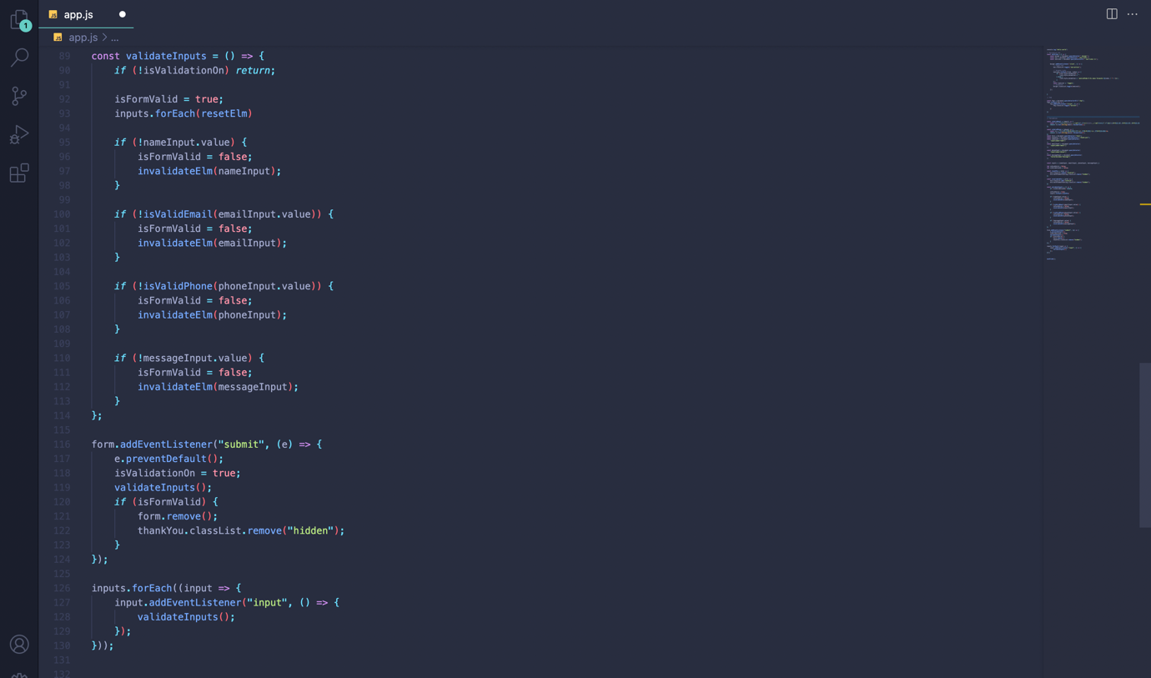

# **Responsiveness**

The website is fully responsive with tablets, mobile phones and different web browsers.

## **Mobile device mode:**

With the mobile device mode there is a dropdown menu which is easier for the user to navigate through the pages. It is done by using JavaScript.

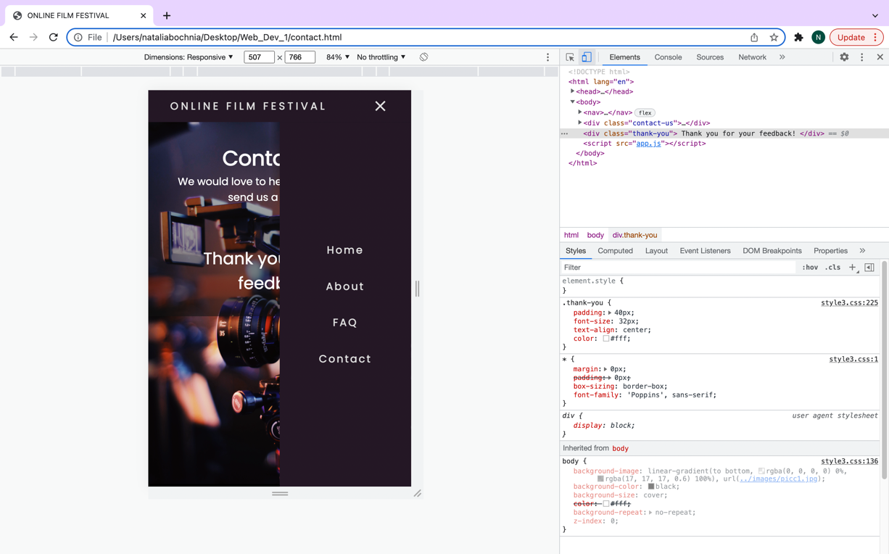

JavaScript code:

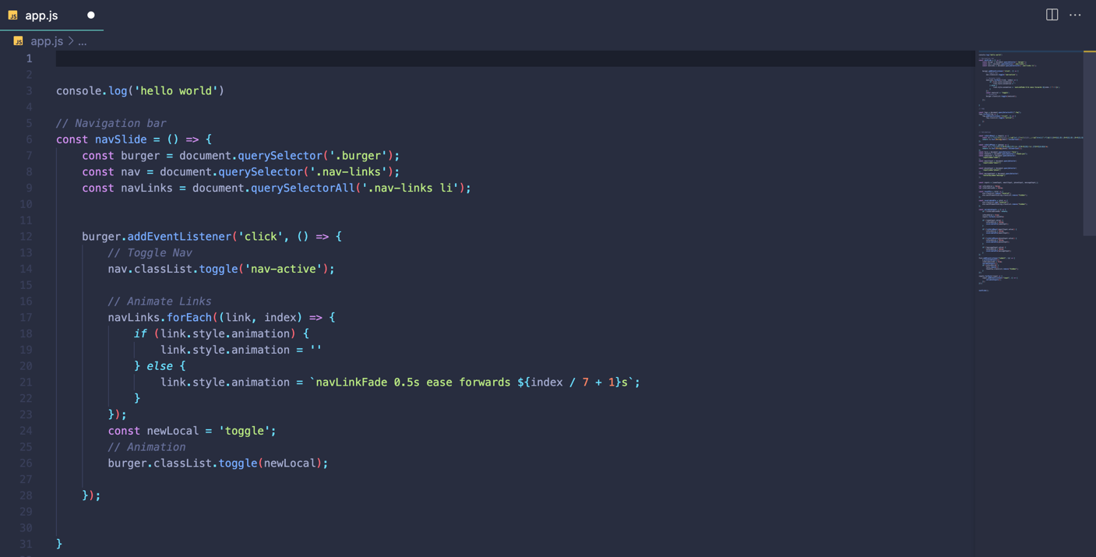

CSS code for responsiveness:

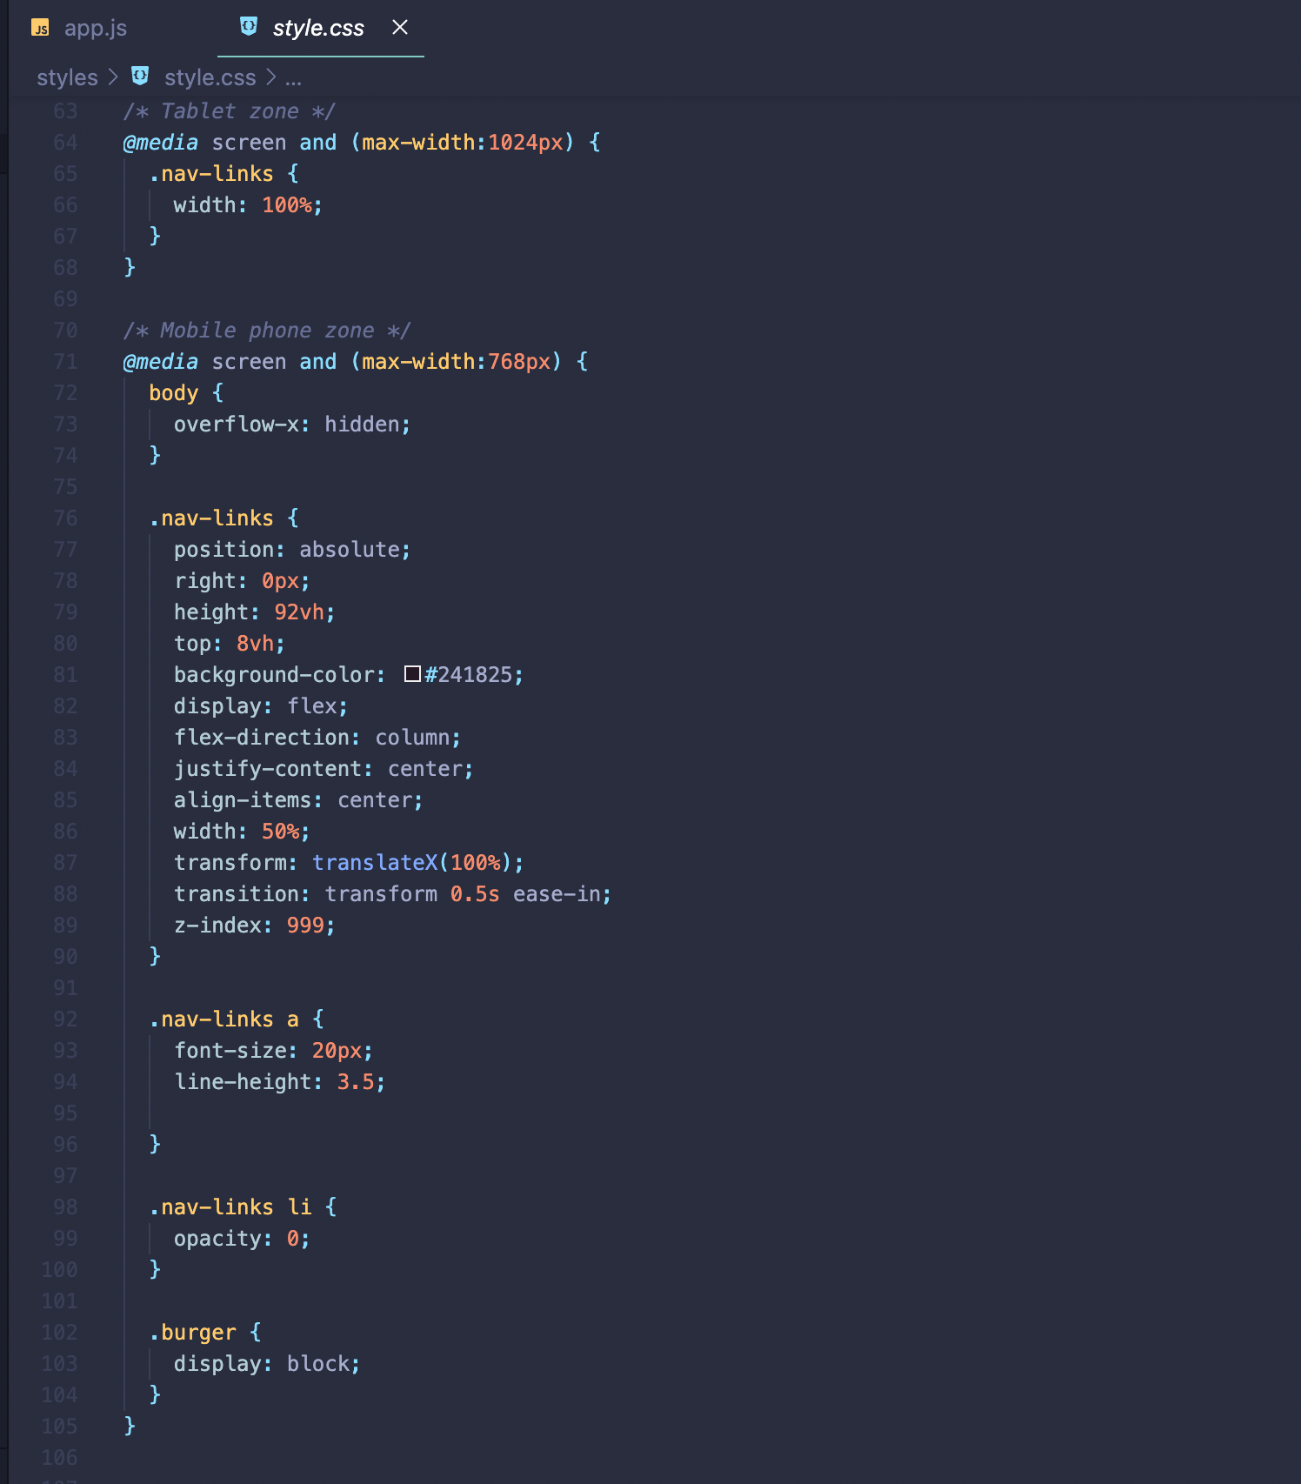

## **Different browsers:**

Chrome:



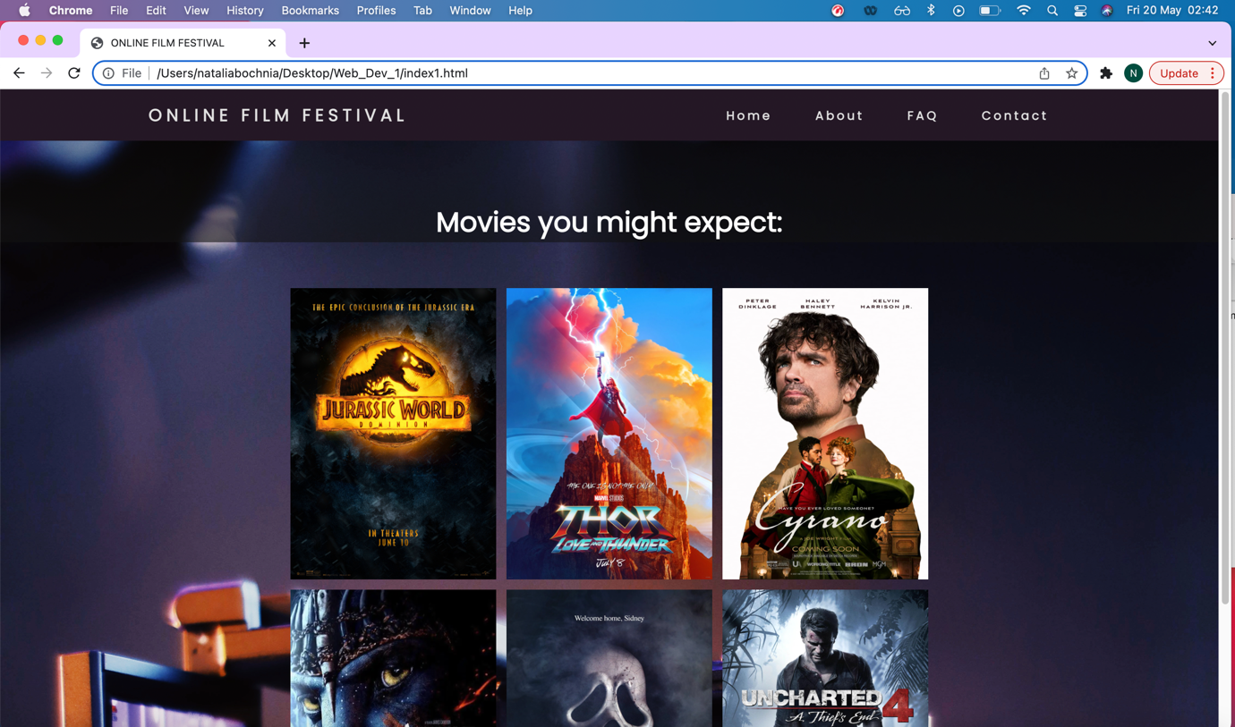



Safari:



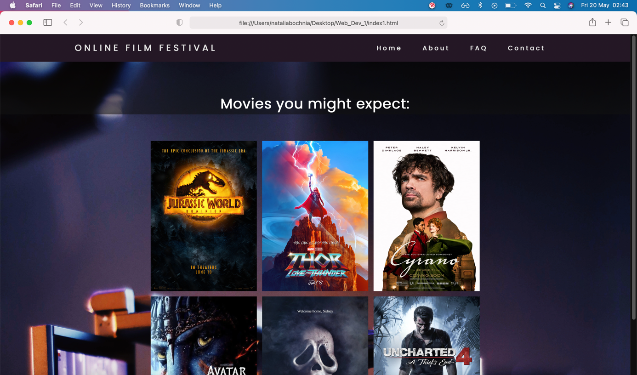

# **Accessibility and legal requirements**

All the images have the alternative text, to make my page more accessible.

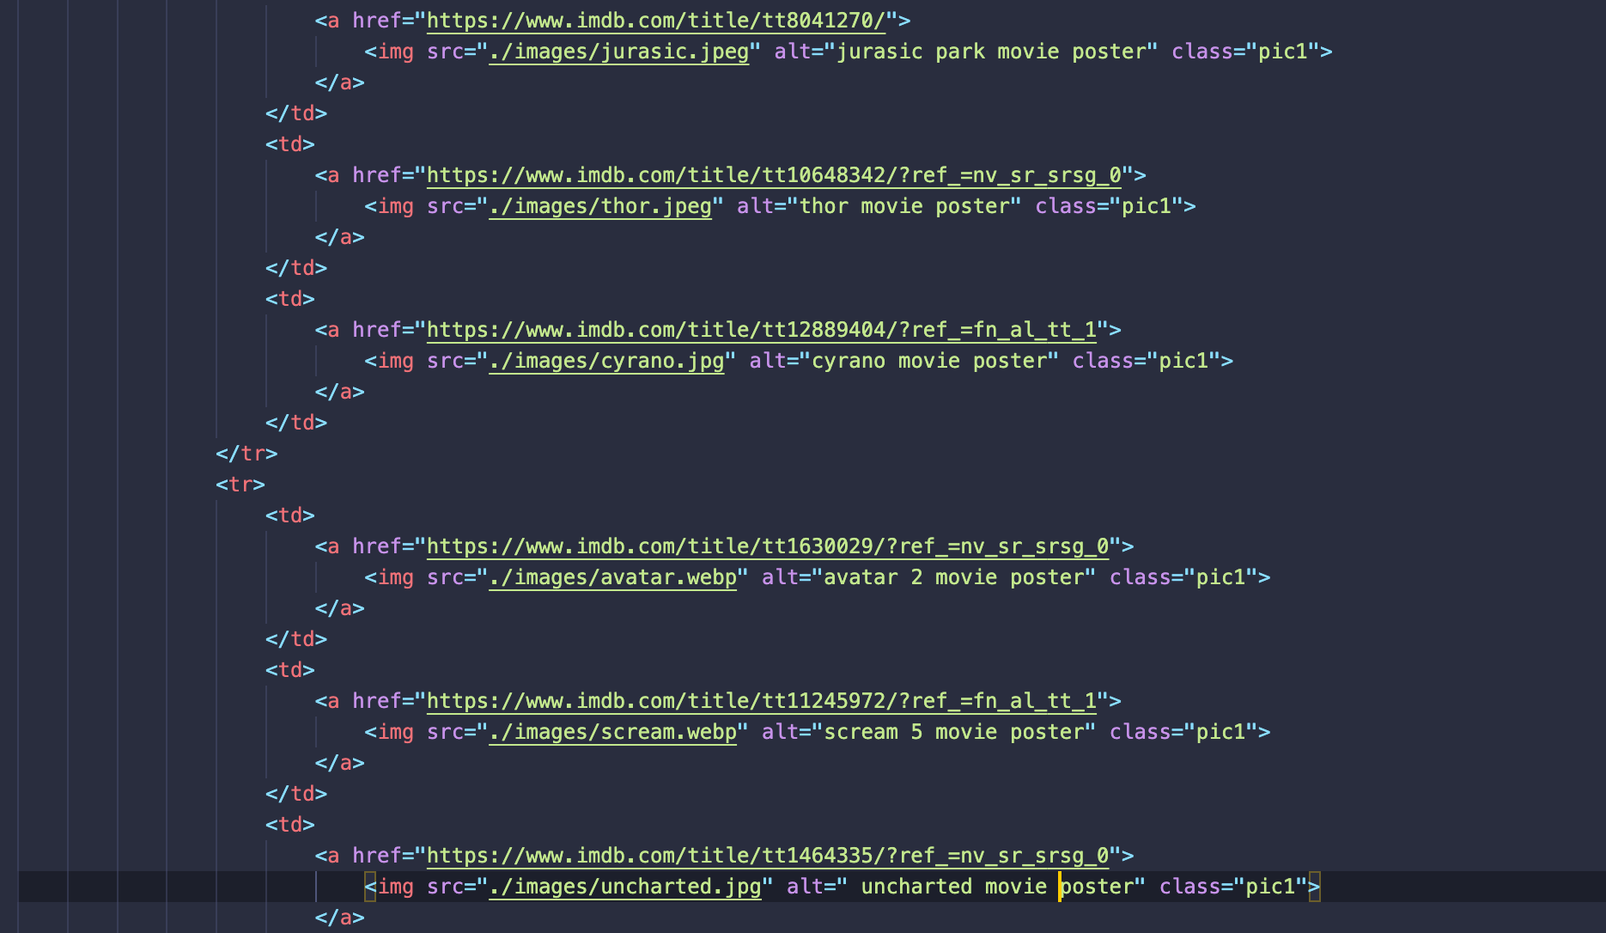

For my body background I used image from pexels.com. Posters images are movie studios property and free to use under “fair dealing” exception. I acknowledge all the rights to the authors.

# **W3school validation:**

I have found only one error, but I left it like that on purpose as my h2 is styled already in the css stylesheet and I really like how this style is affecting my *frame* div.